 |  | ST. ANDREW’S JUNIOR COLLEGE  Higher 1  PRELIMINARY EXAMINATION 2010
Name |  |  |  |  |  |  | Class
CHEMISTRY  PAPER 2  Candidates are to answer Section A on the Question Paper. |  |  |  |  |  |  | 8872/ 02  16 September 2010  2 hours
Additional Materials: |  |  | Writing paper  Data Booklet
READ THESE INSTRUCTIONS FIRST
Write your name and class on all the work you hand in.
Write in dark blue or black pen on both sides of the paper.
You may use a soft pencil for any diagrams, graphs or rough working.
Do not use staples, paper clips, highlighters, glue or correction fluid.

Section A
Answer all questions.

Section B
Answer any two questions on separate writing paper.

At the end of the exam, fasten all your work securely together.
The number of marks is given in brackets [] at the end of each question or part question.
 |  |  |  |  |  |  |  | For examiner’s use
 |  |  |  |  |  |  |  | Section A |  | / 40
 |  |  |  |  |  |  |  | B6
 |  |  |  |  |  |  |  | B7
 |  |  |  |  |  |  |  | B8
 |  |  |  |  |  |  |  | Total |  | / 80
This paper consists of 15 printed pages and 1 blank page.
Section A
Answer all questions.

1 | Sodium peroxodisulfate, Na₂S₂O₈, is commonly used as a bleaching agent in hair cosmetics.
 | (a) | Given that peroxodisulfate oxidises iodide solution to form black crystals, while it is reduced to form SO, construct a balanced equation.
 |  |  |  | [1]
 | A quality control experiment was set up to monitor the current level of peroxodisulfate in the air of the laboratory to ensure that it does not reach hazardous levels (above 1000 mg dm⁻³).
 | (b) | 25 cm³ of air was bubbled into 250 cm³ of water and 25 cm³ of this solution was taken to titrate against a standard solution of potassium iodide, with known concentration of 0.0025 mol dm⁻³.
 |  | (i) | Assuming that all of the peroxodisulfate particles were dissolved into the solution, and that it took 10.25 cm³ of iodide solution to fully react with the peroxodisulfate present, calculate the mass of peroxodisulfate in 1 dm³ of air.
 |  | (ii) | Comment on whether the laboratory needs to be temporarily closed down for disinfection.
 |  | ……………………………………………………………………………...……………………………………………………………………………… |  | [3]
1 | (c) | The reaction between peroxodisulfate and iodide is slow. However, when trace amounts of iron(II) nitrate was added, the reaction took place readily. With the aid of a relevant diagram, explain the observations above and state the role of iron(II) nitrate.
 | ……………………………………………………………………………………...……………………………………………………………………………………...…………………………………………………………………………………… |  |  | [4]
 |  |  | [Total: 8]
2 | (a) | Steel became an important resource with global modernisation. It is used as materials for building skyscrapers, bridges and ships. But iron upon exposure to the elements, would begin to corrode, forming rust. Since ships’ hulls are in constant contact with salt water and sunlight, bars of zinc were welded to the hull as an attempt to ‘protect’ the iron from corrosion.  FeO + Zn → Fe + ZnO  Another material, such as aluminium, is also able to perform similar function.
 |  | (i) | Write a balanced reaction between iron(II) oxide and aluminium.
 |  |  | [Turn Over
2 | (a) | (ii) | Using the data below, hence calculate the enthalpy change for the reaction proposed.  ∆H_{f}(FeO) = –272 kJ mol⁻¹  ∆H_{f}(Al₂O₃) = –1676 kJ mol⁻¹
 |  |  |  | [2]
 | (b) | This reaction could also be used to extract iron from its oxide. Assuming that excess iron(II) oxide was used during the reaction, suggest a chemical reaction that could be used to remove the aluminium product from the reaction vessel, with the aid of a relevant chemical equation.
 |  |  |  | [3]
 |  |  | [Total: 5]
3  0.08  0.06  0.04  0.02 | An investigation was done to determine the kinetics of the reversible endothermic reaction between compounds A and B.  The result of the investigation was tabulated and the following graphs were obtained.  [A] / mol dm⁻³  [A] / mol dm⁻³  0.16  [B] = 1.0 mol dm⁻³  4  8  20  0.12  0.08  [B] = 2.0 mol dm⁻³  0.04  time / min  2  4  6  8  10  time / min  12  16
 | (a) | Determine the order of reaction with respect to [A] and [B] respectively.
 |  |  |  | [2]
 | (b) | Comment on the use of the high concentration of B in the above experiments.
 |  | ……………………………………………………………………………………………………………………………………………………………… |  | [1]
 |  | [Turn Over
3 | (c) | Calculate the rate constant, given that the initial rate for the graph on the left is 1.39 x 10⁻² mol dm⁻³ min⁻¹, stating its units clearly.
 |  |  |  | [2]
 | (d) | Suggest a change in condition to increase the amount of D collected.
 |  | ………………………………………………………………………………  ……………………………………………………………………………… |  | [1]
 |  | [Total: 6]
4 | (a) | The following compound, compound F, was synthesised from benzene through a series of reactions.  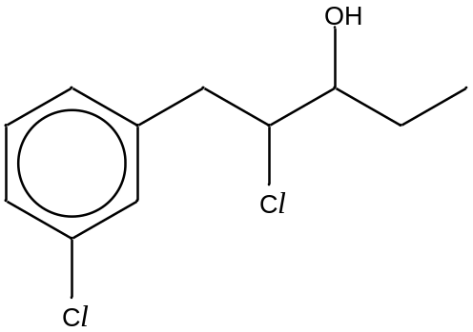  a  b  compound F  Identify two different functional groups present in the compound.
 |  | - ……………………………………………………………………  - …………………………………………………………………… |  | [2]
4 | (b) | In the table below, write down the type of hybridisation expected, the bond angles a and b, and give a sketch of a hybrid orbital exhibited by each of the respective carbon.

Carbon | Type of hybridisation | Bond angle | Sketch of a hybrid orbital
a
b
[3]
 | (c) | During the synthesis of the compound F, a by-product, compound G, was formed.  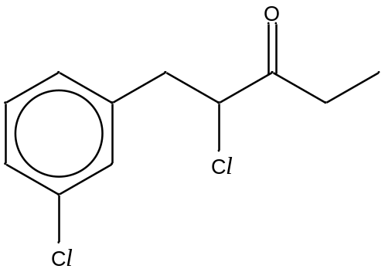  compound G  Suggest a simple chemical test to distinguish between compounds F and G. State the reagents and conditions needed, the observations that you would make, and write a balanced equation for the positive test.
 |  |  |  | [3]
[Total: 8]
[Turn Over
5 | (a) | Complete the reaction scheme below by writing the structural formulae of the organic compounds H – L and stating the reagents and conditions needed for Steps I, II and III in the following tables.
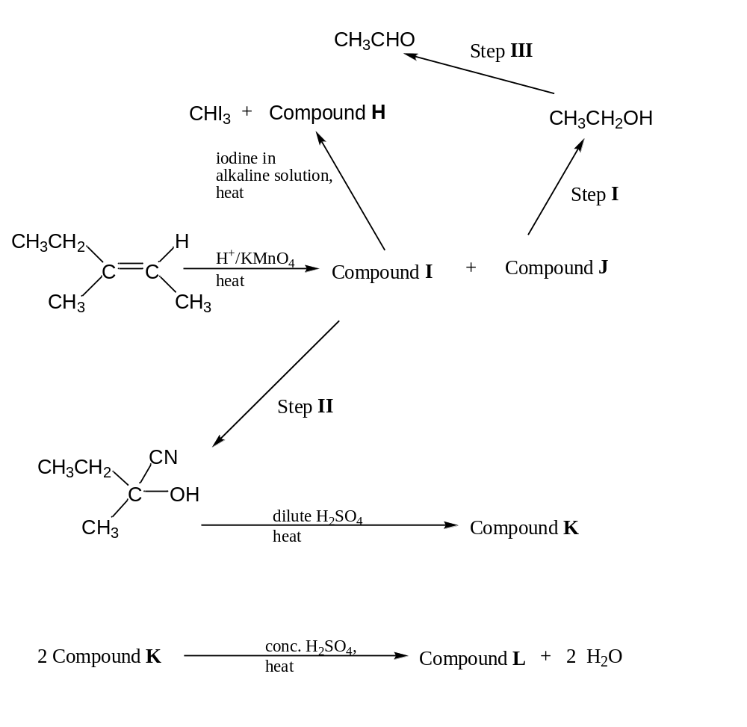

Compound H | Compound I
Compound J | Compound K
Compound L

Step | Reagent | Condition
I
II
III
[8]

[Turn Over
5 | (b) | Compound K, upon dehydration with excess concentrated sulfuric acid at 180 ºC, produces 3 different organic isomers M, N, and O. Isomer M is a structural isomer of isomers N and O.
 |  | (i) | Draw the displayed formulae of isomers M, N, and O.
 |  | (ii) | Using your structures of isomers N and O, suggest and explain which has the higher boiling point
 |  | ………………………………………………………………………………  ………………………………………………………………………………  ……………………………………………………………………………… |  | [5]
 |  | [Total: 13]

End of Section A
Section B

Answer 2 out of 3 questions.

6 | (a) | A student wants to identify an unknown Group I metal, P, within a sample of hydrogen carbonate, PHCO₃. After doing some research, she found a decomposition reaction that would suit her purpose. The decomposition reaction is shown as:  2 PHCO₃(s) → P₂CO₃(aq) + H₂O(l) + CO₂(g)  She heated a 5.00 g sample of PHCO₃ in a boiling tube, and bubbled the gas evolved into a solution of calcium hydroxide (concentration 1.0 mol dm⁻³). A white precipitate formed was found to have a mass of 1.70 g. Calculate the molar mass of PHCO₃ and hence identify P. |  |  | [3]
 | (b) | A standard solution of propanoic acid was made by pipetting 20.0 cm³ of propanoic acid, labelled solution Q, which was then made up to 250 cm³ with deionised water (labelled solution R). Solution R was then used to react with solid PHCO₃. It was determined that 34.50 cm³ of solution R was needed to react with 0.293 g of solid PHCO₃ completely. Calculate the concentration of propanoic acid in solution Q. |  |  | [2]
 | (c) | Given that solution Q contains only propanoic acid and its pH was 2.50 under room temperature and pressure (r.t.p.) conditions, calculate the acid dissociation constant of propanoic acid. |  |  | [1]
 | (d) | Both propanoic acid and butan-1-ol have the same relative molecular mass, but have different pH values when the same amount was dissolved in 1 dm³ of solution. Explain, with the aid of relevant equations, which would have a lower pH value. |  |  | [3]
 |  | [Turn Over
6 | (e) | Butan-1-ol, with a molecular formula of C₄H₁₀O, can be converted into its various structural, positional and functional isomers through the aid of a catalyst and heat. A sample of butan-1-ol was heated to form 2 different structural isomers (compounds S and T).  Compound S can decolourise hot acidified potassium manganate(VII) solution. The oxidised product, labelled compound U, could form an orange precipitate with 2,4-dinitrophenylhydrazine solution.  A single isomer C₄H₉OCl was formed when compound T when reacted with a limited supply of chlorine gas under intense light.
 |  | (i) | Identify and draw the displayed formulae of compounds S, T and U.
 |  | (ii) | State the observations that could be made and illustrate your answer with the aid of balanced equations, when
 |  |  | I | compound S was added with hot alkaline iodine solution;
 |  |  | II | compound T was added to PCl₅ at room temperature and pressure conditions; and
 |  |  | III | butanal, an oxidised product from butan-1-ol, was added with hot Fehling’s solution.
 |  |  |  |  | [11]
 |  |  | [Total: 20]
7 | (a) | Aluminium chloride is used as a catalyst in organic chemistry. Use dot-and-cross diagrams to illustrate the structures of aluminium chloride and its dimer, Al₂Cl₆, and state the shapes and bond angles around the aluminium atom(s) in each structure. |  |  | [4]
 | (b) | The reaction between gaseous chlorine and benzene is catalysed by the presence of AlCl₃. Describe, with the aid of a balanced equation, why the reaction would not likely take place when aqueous chlorine was used instead. |  |  | [2]
7 | (c) | Another commonly used catalyst for this reaction is FeCl₃ and it exists as various isotopes such as ⁵⁴FeCl₃ and ⁵⁶FeCl₃. Write the electronic configuration of Fe in ⁵⁶FeCl₃. |  |  | [1]
 | (d) | A student investigated the kinetics of the reaction between FeCl₃, Cl₂ and benzoic acid and the following information was obtained.

Experiment No. | [FeCl₃]  / mol dm⁻³ | [Cl₂] / mol dm⁻³ | [benzoic acid]  / mol dm⁻³ | Rate  / mol dm⁻³ min⁻¹
1 | 0.100 | 0.075 | 0.250 | 1.39 x 10⁻⁵
2 | 0.100 | 0.100 | 0.250 | 1.85 x 10⁻⁵
3 | 0.150 | 0.075 | 0.300 | 2.50 x 10⁻⁵
4 | 0.150 | 0.100 | 0.250 | 2.78 x 10⁻⁵

 |  | (i) | Determine the order of reaction with respect to FeCl₃, Cl₂, and benzoic acid. Hence write the rate equation and determine the rate constant of the reaction using information from experiment 3.
 |  | (ii) | Sketch a labelled energy profile diagram for this reaction. | [7]
 | (e) | Suggest reagents and conditions for the 4-step synthesis of 3-oxo-butanoic acid from propene. |  | [6]
 |  |  | [Total: 20]
 |  |  | [Turn Over
8 | (a) | Sulfur, S₈, in its yellow solid state, exists in a variety of oxidation states in its compounds. One of them is that of sulfur dioxide, which is readily formed during a volcanic eruption or during the combustion of fossil fuels. Using the relevant information from the Data Booklet, and given the following data, calculate the bond energy of S=O in sulfur dioxide.  S₈(s) → S₈(g) ∆Hº = +120 kJ mol⁻¹  ∆H_{f}(SO₂(g)) = –296 kJ mol⁻¹ |  | [2]
 | (b) | The key reaction during the Contact process, for manufacturing sulfuric acid, is as follows:  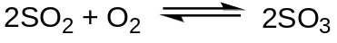  A 3 dm³ vessel was used and 4 moles of sulfur dioxide and 4 moles of oxygen were introduced into the vessel. Given that the exothermic reaction, under the conditions of 450 ºC, 2 atm pressure and presence of vanadium(V) oxide, ensured a 96% conversion, calculate the K_{c} of the reaction. |  | [3]
 | (c) | Predict and explain the changes to the yield and the K_{c} value if the following changes were made:
 |  | (i) | temperature was reset to 200 ºC; and
 |  | (ii) | 2 moles of SO₂ were added. | [5]
 | (d) | A 25 cm³ portion of the equilibrium mixture in the above part was extracted and dissolved in 1 dm³ of distilled water, forming a mixture labelled as mixture V. Given that sulfurous acid, H₂SO₃, is a weak dibasic acid, calculate the volume of 1.5 mol dm⁻³ sodium hydroxide solution required to completely neutralise the mixture V and suggest a possible indicator to be used. |  | [4]
8 | (e) | Suggest a chemical test to distinguish the compounds in each of the following pairs, stating clearly all observations and balanced equations for positive tests. |  | [6]

 | Compound W | Compound X
(i) | 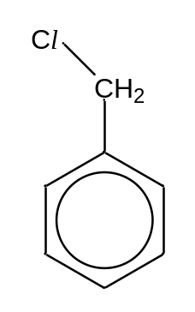 | 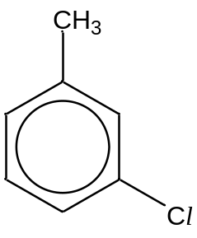
(ii) | 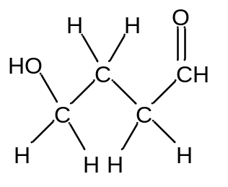 | 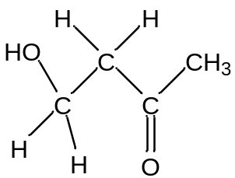

End of Paper 2
BLANK PAGE

